# Using Packet tracer, create a network of 4 computers, which are connected through a hub. Provide, proper configuration of IP addresses and show that the communication between any two computers are successful.

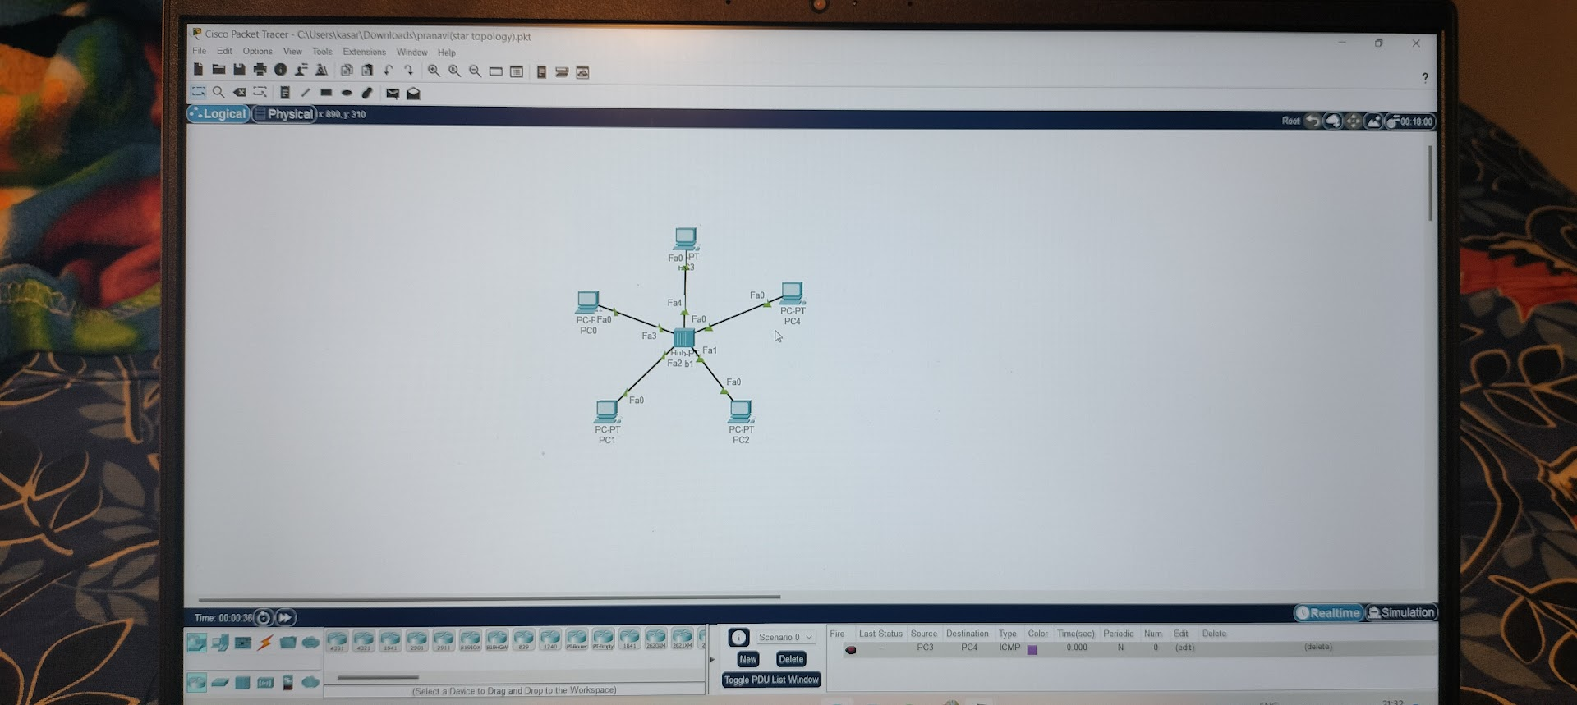

# Using Packet tracer, create a network of 5 computers, where all the computers are connected with all the other computers. Use appropriate connection links and provide , proper configuration of IP addresses and show that the communication between any two computers are successful.

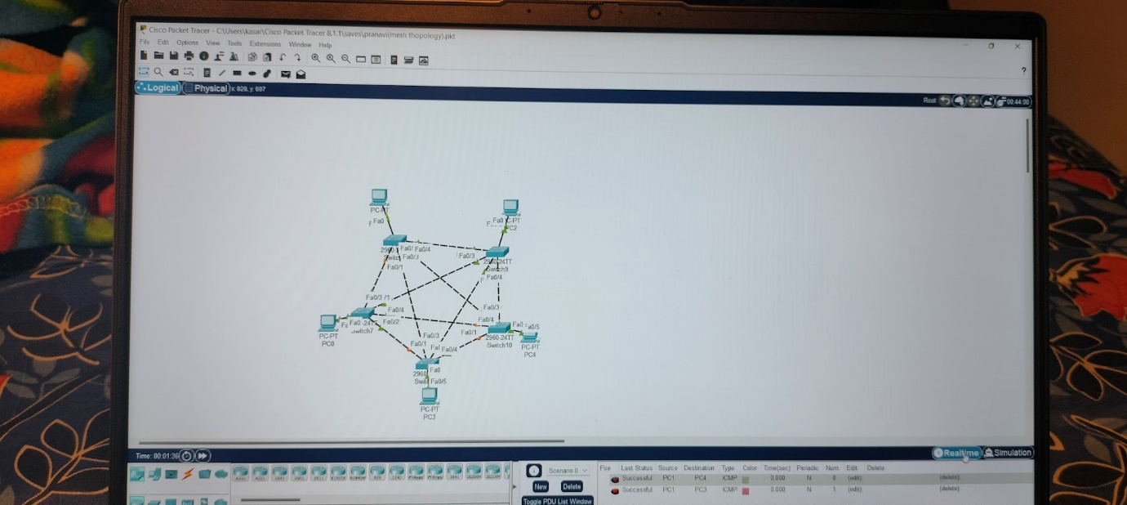

# 3. Using Packet tracer, create a network of 4 computers, where all the computers are connected in a circular manner with other computers. Use appropriate connection links and provide , proper configuration of IP addresses and show that the communication between any two computers are successful.

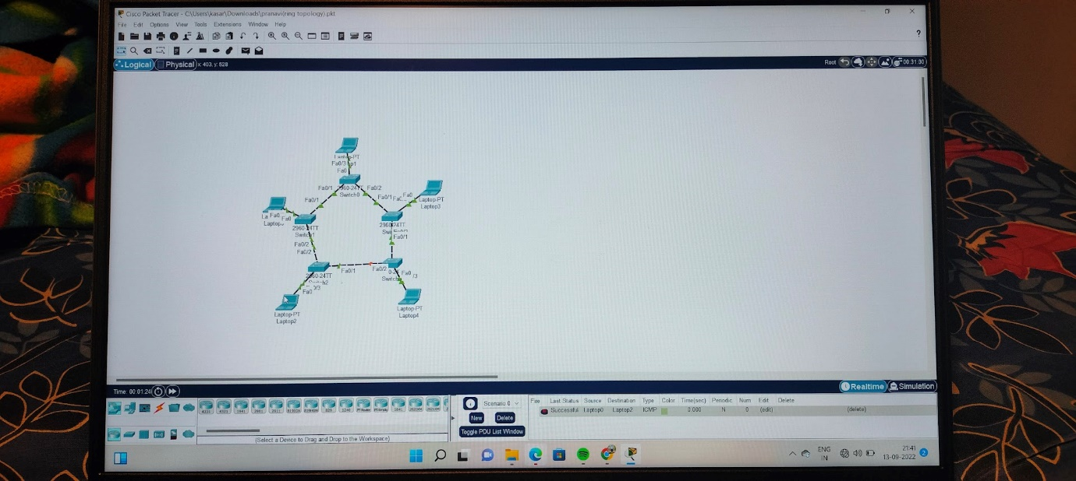

# 4.Using Packet tracer, create a network of 6 laptops, where all the computers are connected in a series . Use appropriate topology , connection links and provide , proper configuration of IP addresses and show that the between any two computers are successful

# 

# 5. Implement a hybrid topology consist of bus and star framework using packet tracer.

# 

# 6. Construct a tree topology with 10 PCs and 4 Switches using packet tracer

# 

# 7. Using Cisco packet tracer, configure a network using address resolution protocol (ARP) and examine the ARP table for the following condition. 1. A request for an ARP Remote communication's ARP process

# 

# 8. Create a scenario in which you configure a Link Layer Discovery Protocol for the given topology and analyse network performance using this address table.

# 

# 9. Using Packet tracer, create a network of 4 computers, where pairs of computers exist on the same network. The computers in the same network should be connected through a PT switch and the two switches should be connected through two generic routers. Use appropriate connection links and provide, proper configuration of IP addresses, default gateway, subnet mask and show that the communication between any two computers, in different networks are successful. Use the principle of static routing

# 

# 10. Using Packet tracer, create a network topology as shown in the below diagram. Use generic routers with appropriate configurations and IP addresses as given in the diagram and demonstrate the principle of working of routing information protocol.

# 

# 11. Using Packet tracer, create a network topology with 4 subnets and 2 routers . Use generic routers with appropriate configurations and IP addresses. Demonstrate the principle of working of OSPF dynamic routing protocol

# 

# 12. Construct a LAN network with 4 subnets with 1 routers using Packet Tracer

# 

# 13. In a network simulator, create a scenario to analyse the performance of the TCP and UDP protocols and use relevant parameters to configure DNS, FTP, Web, and Email Servers. Assume the required parameters

# 

# 14Create a scenario to analyse the performance of the TCP and UDP protocols by establishing a session between client and server.

# 

# 15. Construct a network to automate the window, fan and smoke detector using Cisco Packet Tracer

# 

# 16. Implement a network to automate the water sprinkler in garden using Cisco Packet Tracer

# 

# 17. Construct a network for 3 companies with wired and wireless routers using Cisco Packet Trace

# 